Victor battery handover document

# Battery emulator for BMS configuration verification

The battery emulator consists of an MCU board and a CMU board. For the final implementation, several CMU boards can be connected in a daisy chain to represent a final battery pack setup, but for debug purposes 1 board suffices to a start.

For component placement and BOM, refer to the following Teams folder: [battery](https://dtudk.sharepoint.com/:f:/r/sites/DTURoadrunnersSolarTeam/Delte%20dokumenter/Electrical%20team/Energy%20Storage/battery?csf=1&web=1&e=qZrD8k)

Should any questions arise, I can be contacted by the following contact information:

Student mail (preferred option until March 2025): [s194027@student.dtu.dk](mailto:s194027@student.dtu.dk)  
Private mail: [victorahansen@hotmail.dk](mailto:victorahansen@hotmail.dk)  
Phone number: (+45) 22 37 44 92

## MCU board

The MCU board is seen in the picture below,

One task remains on the MCU board before it is ready for testing:

During the soldering work, two resistors (110k and 158k) were overseen when placing the components, as can be seen in the picture with the red circle. These resistors are important to obtain the correct amplitude for the emulated current sensing. If necessary, remove the switch next to the pads to have more space for working.

After this task is completed, it is recommended to prove the board to check for any bad soldering.

## CMU board

The CMU board is seen in the picture below,

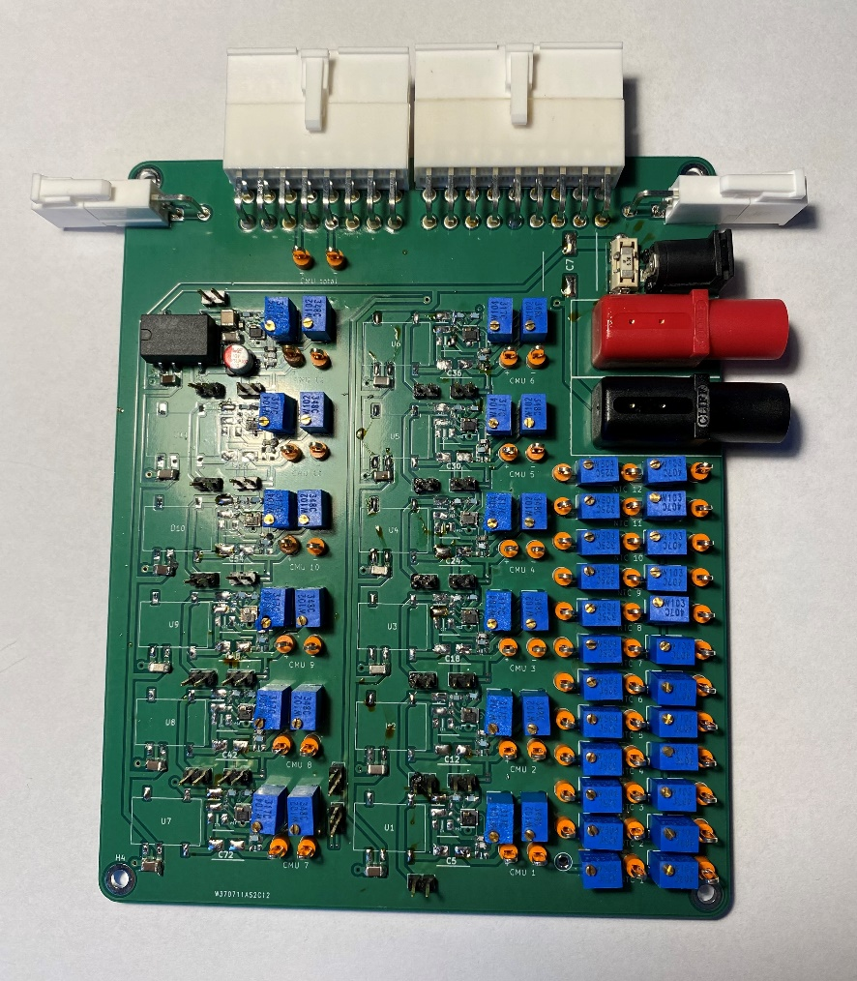

Some component soldering is needed to obtain a fully functional board. The board consists of 12 rows with galvanic isolation to obtain 12 independent voltages. The row in the top left (CMU 12) is fully done but has not been tested.

The other rows have several components attached which seems to be the most difficult to place, however, it is highly advised to probe around the DC/DC converter, as it is placed by pad connections beneath the component making it difficult to control that the connection is in order.

The pictures below show the completed row and the components that are placed on the other rows.

# Solar panels for the car

Investigation of flex panels have been conducted with Oliver Asger Hjortshøj Schreyer having lead on contacts with potential partners. As no panels have been found at the time of this writing, it is proposed to use some flexible retail panels that can be mounted on the car such as <https://www.biltema.dk/bil---mc/elsystem/solcellepaneler/solpanel-bojelig-50-w-2000042492>. These panels have little documentation but can serve as proof of concept until better and more suited panels have been found. A MPPT controller can be bought alongside the panels or made by a student project.

## MPPT algorithm

In terms of the algorithm that must control the panels, there are several options.

One of the simplest algorithms is the perturb and observe algorithm which is easy to implement. The downside is that it might not always find the peak efficiency point in cloudy weather or if any obstructions cover parts of the panels. In such cases, more complex algorithms which scan the entire V-I curve of the panels can be used to find the best operating point.

However, perturb and observe could arguably be effective when considering that the panels are mounted on a moving car which means rapid changes to the solar radiation the solar panels are exposed. The perturb and observe are great for rapidly changing conditions, but further investigations into the MPPT options must be conducted before any conclusion can be made.